Name:

Information: We have learned about scale factors with geometric shapes. Now let’s apply this knowledge to different size candy bars and even nutritional values.

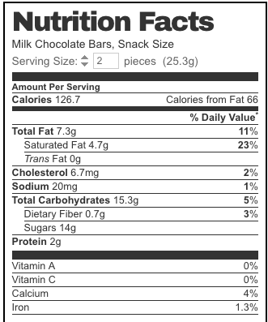
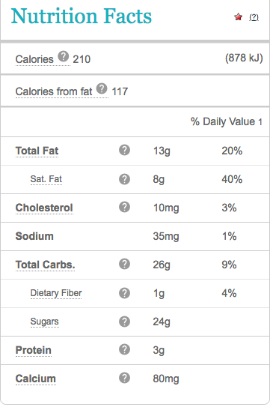

Snack Size Chocolate Bar
Normal Size Chocolate Bar

Steps for Part 1:

1). Using a ruler, measure the length and height of your candy bar and record the values below.
2). The length of a normal sized candy bar is on the board.
3). Determine the scale factor between the snack size Hershey’s bar and the normal size Hershey’s bar
4). for the length, width and height of the normal size candy bar to your candy bar. When determining the scale factor, write an equation in the box and show all work!

Candy Bar Information | Snack Size | Normal Size Candy Bar | Scale Factor (Show Work!!)
Length

Using the scale factor you found, find the height and width of a normal sized candy bar.

Height of Normal Candy Bar:

Width of Normal Candy Bar:

Part 2:
1). Copy the nutritional information of your candy bar in the column labeled original size
2). Using the scale factor found in Part 1, find the theoretical nutrition facts and fill in the values in the column labeled theoretical nutrition facts.
3). Copy the actual nutrition facts for a normal sized candy bar into the column labeled Actual Nutrition Facts for Normal Size Candy Bar
4). Are the actual values and the theoretical values the same? If not, find the scale factor between the Snack Size nutrition facts and the Actual Size nutrition facts.

Candy Bar Information | Original Size Candy Bar | Theoretical Nutrition Fact | Actual Nutrition Facts for Normal Size Candy Bar Nutrition Facts | Scale Factor (Show Work!!)
Calories | 126.7 |  | 210
Total Fat
Cholesterol
Sodium
Total Carbohydrates
Protein

Is the Snack Size candy bar and exact scale model of a normal sized candy bar?? Why or why not?

